INTEGRATED BEHAVIOR QUANTIFICATION SYSTEM FOR THE MEASUREMENT OF MOVEMENT KINEMATICS AND NEURAL ACTIVITY IN THE STRING PULLING TASK

by

Gianna Jordan

____________________________

Copyright © Gianna Jordan 2021

A Thesis Submitted to the Faculty of the

DEPARTMENT OF BIOMEDICAL ENGINEERING

In Partial Fulfillment of the Requirements

For the Degree of

MASTER OF SCIENCE

In the Graduate College

THE UNIVERSITY OF ARIZONA

2021

**Acknowledgements**

I would like to first that my mentor, Dr. Stephen Cowen who guided me along this process. Thank you for showing me how to celebrate my successes, remain resolute in the face of setbacks and failures, and for providing me an environment where I could get excited and truly have fun with the work I was doing. I would also like to thank my committee members Dr. Torsten Falk and Dr. Andrew Fuglevand for lending your guidance and expertise and making me a better scientist and engineer. Thank you to Abhilasha Vishwanath, Dr. Mitchell Bartlett, Deip Sekhadia, and all the others who worked on this project with me and helped in this systems' development. I would also like to give thanks to Nura Dualeh and Dr. Franz Tax, I truly would not have been able to do this without your support and encouragement.

Contents

**Abstract** 5

**Keywords** 5

**1. Introduction** 6

**2. Material and Methods** 11

**2.1 System Design** 11

**2.1.1 Video Camera** 14

**2.1.2 Rotary Encoder** 14

**2.1.3 Behavior Metric Synchronization with Neural Activity** 16

**2.1.4 Motion Tracking with DeepLabCut** 17

**2.1.5 Behavioral Segmentation** 18

**2.2 Animals** 21

**2.3 Stereotaxic Surgeries** 21

**2.4 Animal Training** 23

**3. Results** 26

**3.1 Validation of Motion Tracking** 26

**3.2 Paw Kinematics** 26

**3.3 Single Units with Preferential Firing** 28

**4. Discussion** 30

**4.1 General Discussion** 30

**4.2 Applications** 31

**4.3 Future Implementations** 33

**4.4 Limitations** 34

**5. Conclusion** 34

**References** 36

# **Abstract**

There are many behaviors used in the study of motor disorders. Simple ones like the rotarod test are easy to implement and give a single measure of behavior. Others, like the center-out task, skilled reaching task, vermicelli handling test, and string pulling task are more complex. These often require manual segmentation of movement to identify motor patterns. We have developed an integrated hardware and software system capable of automatically controlling and quantifying behavior in the string pulling motor task. This system also integrates with neural recording systems to allow for the syncing of behavioral states to neural responses. Our system also streamlines the training of this behavior by allowing the automated shaping of animals. Key elements of the hardware included 3D-printed parts, a high-speed camera, a rotary encoder, an Arduino microcontroller, and custom circuits. Open-source deep-learning software (DeepLabCut) was used to record paw and head movements and custom software used this information to further categorize the phases and segments of each pull. Using this system, we were able to identify 97 neurons that were significantly responsive to right paw motion, 83 neurons that were significantly responsive to left paw motion, and others that were responsive to other components of the string pulling task. This system has applications in the study of motor control, motivation, and motor disorders such as Parkinson’s Disease, Huntington’s Disease, and strokes.

# **Keywords**

Behavior quantification, motor disorder, automation, open-source, single unit

# **1. Introduction**

Deficits in animal models of motor disorders have been shown to be similar to that in humans (Whishaw et al., 2002) and learned motor behaviors have been studied in animals for easier therapy translation to humans with conditions such as Parkinson’s Disease, Huntington’s Disease, and strokes (Klein et al., 2012). Specifically in rodents, behaviors such as skilled reaching, where animals make reaches with one arm to receive a food reward (Whishaw & Pellis, 1990); the center-out task, where animals move their hands from the center of a circle to a designated stop point on its edge (Georgopoulos et al., 1982); the vermicelli handling test, where animals manipulate pieces of pasta with their forepaws (Allred et al., 2008); the rotarod test, where rodents try to balance on a rotating rod (Dunham & Miya, 1957); and the string pulling task, where animals make hand-over-hand motions to pull a string and receive a reward (Blackwell, Köppen, et al., 2018) are just some of the behaviors used. Each task, however, has its own set of limitations. For instance, the rotarod test produces only one behavioral outcome measure (time to fall) which limits the capacity to evaluate fine motor control. In contrast, single-arm tasks such as the center-out test or skilled reaching task, involve complex grasping behaviors (Georgopoulos et al., 1982; Whishaw & Pellis, 1990); however, these tasks are difficult to quantify and typically require manual image segmentation. Furthermore, these tasks can be compromised when animals have a preferred limb due to natural preference or to a lesion/manipulation (Klein et al., 2012; Parmiani et al., 2019). For example, limb preference can slow training on the task and compromise the evaluation movements. Bimanual tasks, such as the vermicelli handling test (Allred et al., 2008), are complex in that they require animals to coordinate paw movements. As with the grasping tasks, assessment of performance on the vermicelli task requires time-intensive manual segmentation of paw movement (Allred et al., 2008) and movement time (Tennant et al., 2010).

String-pulling tasks have been used to assess behavior for decades and in more than 160 species (Jacobs & Osvath, 2015). Even so, string-pulling behaviors have only recently been used to evaluate fine motor control (Blackwell, Banovetz, et al., 2018; Blackwell, Köppen, et al., 2018; Blackwell, Widick, et al., 2018) and motivation. In versions of this task that have been optimized for rodents, animals make hand-over-hand movements to pull down a string and receive a reward. This bimanual motion is similar to motions naturally performed by animals when pulling nesting material or plants for food (Blackwell, Banovetz, et al., 2018). Perhaps for this reason, simple versions of this task take less than one week for animals to learn (Blackwell, Köppen, et al., 2018).

String-pulling tasks have many advantages over traditional tests of motor function in rodents. The first advantage of the task is the short training time required to bring rodents to proficiency; rodents can be taught the task in a matter of days to a couple weeks (Blackwell, Banovetz, et al., 2018). The task also necessitates the use of both limbs, so even if animals have deficits in one limb, performing the task efficiently requires them to attempt to use both. Animals performing this task are also in a relatively stable and upright position, which makes video recording and position scoring easier after the behavior is administered.

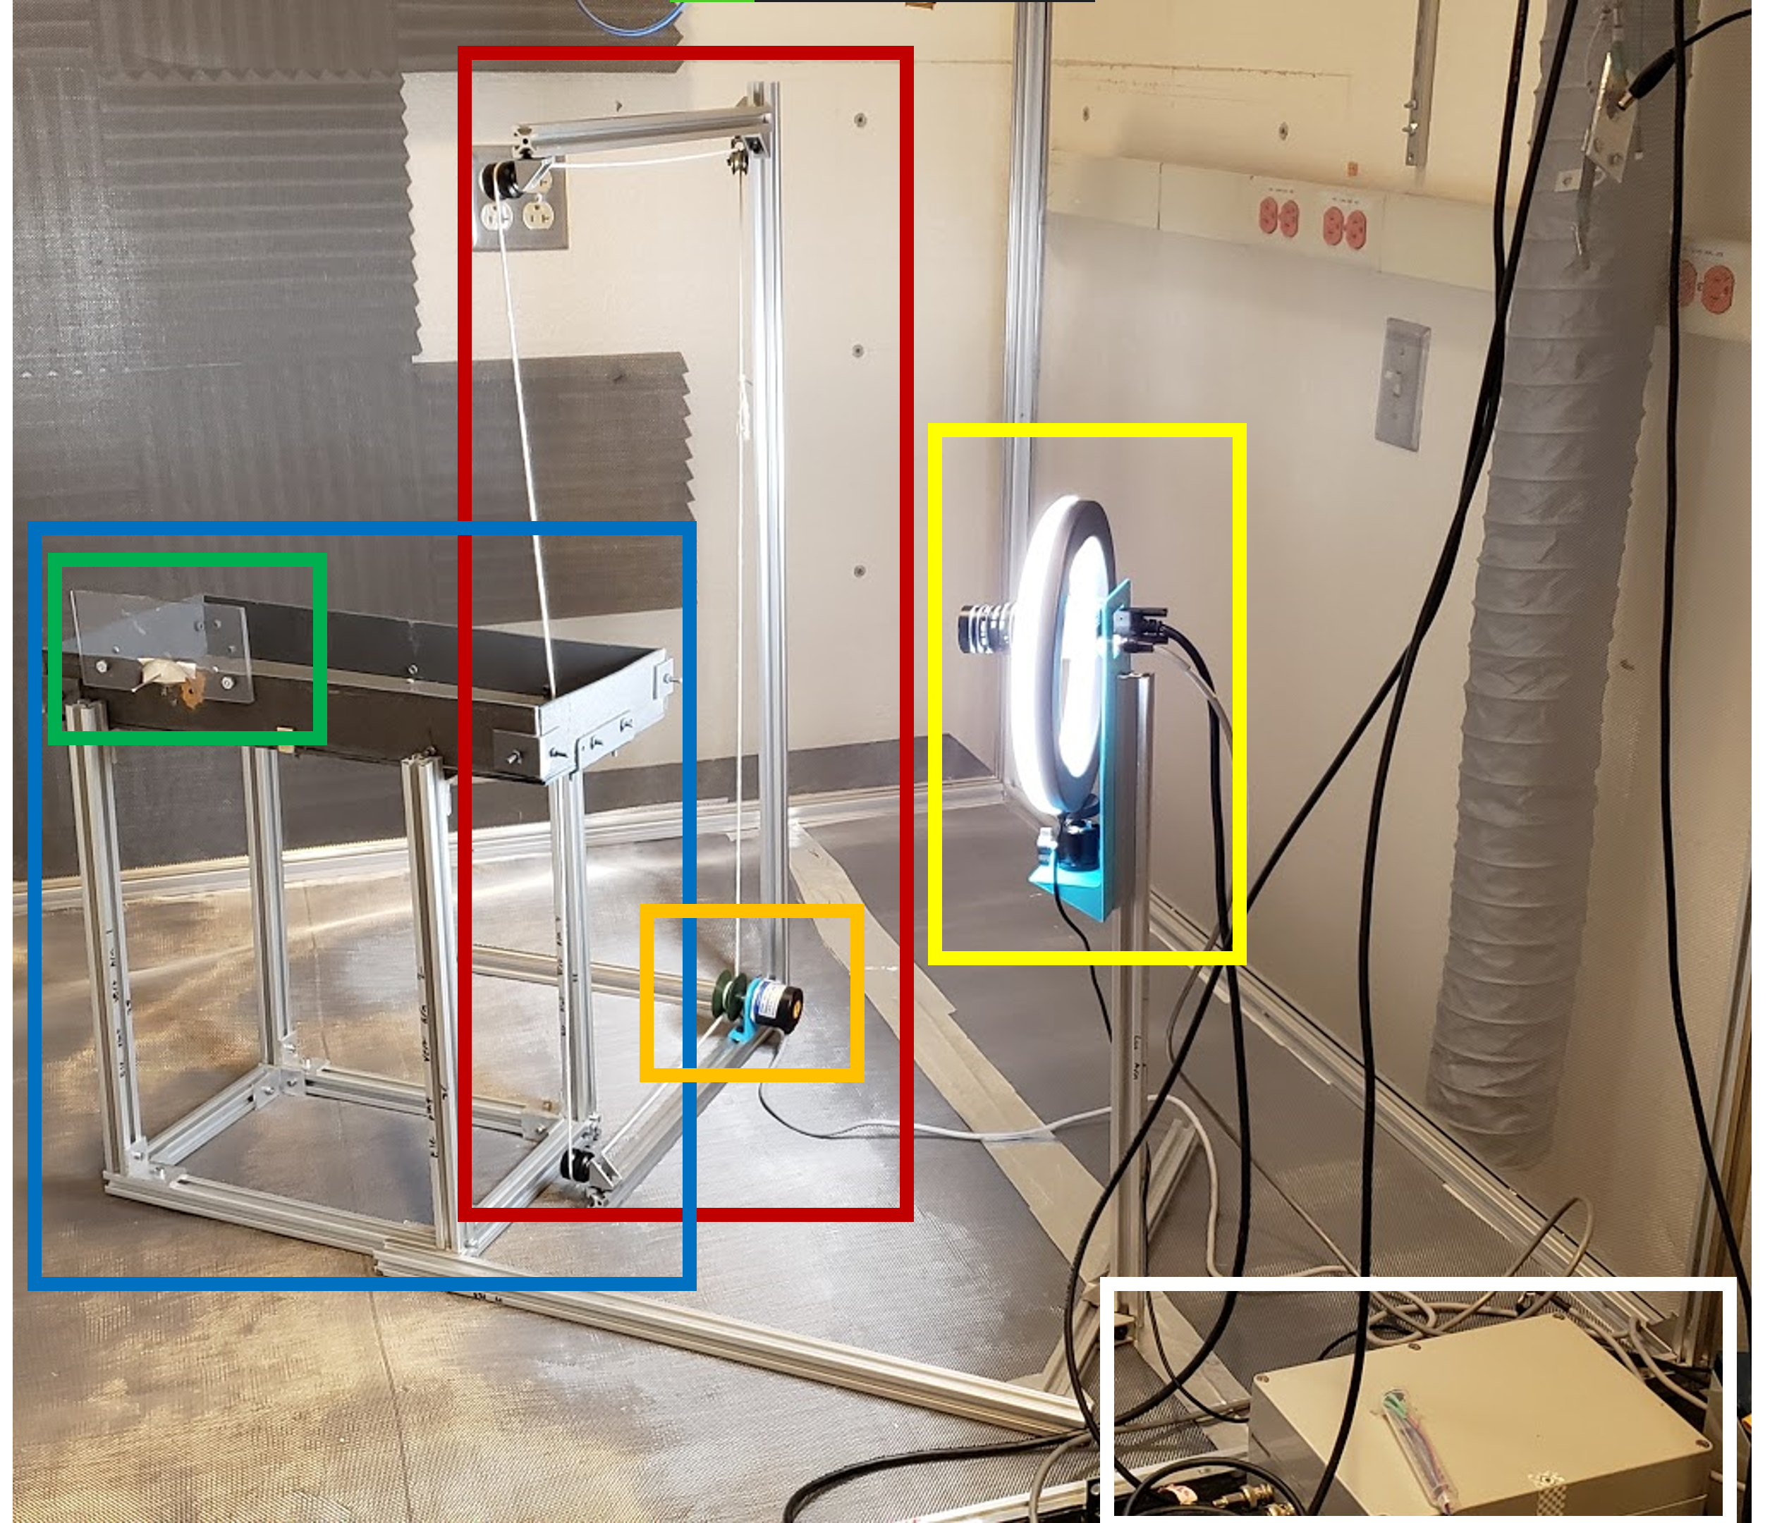

**Figure 1:** Integrated Behavior Quantification System hardware for string pulling task administration. Our modifications from the traditional setup include an infinite loop of string (RED) positioned around a series of pulleys and a rotary encoder (ORANGE), an elevated platform (BLUE), an automatic feeder (out of frame) and well to hold dispensed food (GREEN), and a high speed camera with a ring light (YELLOW). All components are controlled through an Arduino (WHITE) and software, apart from the camera that is controlled through the Matlab Image Acquisition Toolbox.

Here, we describe an integrated hardware (**FIGURE** 1) and software system for controlling and studying motor behavior in the string pulling task. This system also implements automatic video segmentation of movement suitable for detailed analysis of paw position, movement phase, and posture. Advantages of our implementation include an “infinite loop” pulley system that is connected to a rotary encoder. This system allows animals to pull for extremely long individual bouts (1-16 meters) and automatically reinforces animals for pulling pre-specified distances by triggering an attached feeder. We have also replaced the traditional cage with an elevated platform, and have added a high speed (367fps) camera. System hardware components are outlined in **TABLE 1** and **FIGURE 1**. Another advantage of the system is that the task requires animals to maintain an upright and forward posture (**Figure 2A**) which facilitates full-body video recording/tracking and movement segmentation. Segmentation of rodent body position from video data in this task and similar tasks (e.g., paw, nose, and body position) has traditionally been performed manually, which is a time intensive and laborious process (Allred et al., 2008; Blackwell, Banovetz, et al., 2018; Blackwell, Köppen, et al., 2018). Recently, automated approaches to the characterization of rodent movements in the string pulling task have been developed (Inayat et al., 2020). In addition, powerful deep-learning approaches to movement segmentation have been developed that can be applied to a wide range of animal behaviors (Mathis et al., 2018). Here we use DeepLabCut to segment paw and nose position and demonstrate how these data can then be synchronized with neural recording data acquired from the rodent motor cortex to identify neurons that respond to specific phases (reach and withdraw) or neurological injuries, such as hemi-lesioned Parkinson’s Disease (PD) rat models. System code, as well as circuit diagrams for reproducing each subsystem, are available on [GitHub](https://github.com/GiaJordan/Behavior_Quantification) (github.com/GiaJordan/Behavior_Quantification). Post processing of the data collected with these systems was done in Matlab 2019b and Python 3.6.

**Figure 2**: **A)** Rat 315 performing the string pulling task on an elevated platform with the “infinite loop” of string. The nose, right paw, and left paw are denoted with blue, green, and red circles, respectively. Circles are position data from DeepLabCut after processing and filtering in Matlab. **B)** Paw Speeds over the entire string pulling bout, a subset of a bout, and a period of 5 seconds within a bout. Subsequent regions of interest are denoted with vertical black bars. Y positions of both paws and times of one motor cortex neuron’s action potentials are also shown for the same 5 second interval. Our system allows for the simultaneous recording of neural activity and behavioral activity without physical markers that interfere with rat activity during performance.

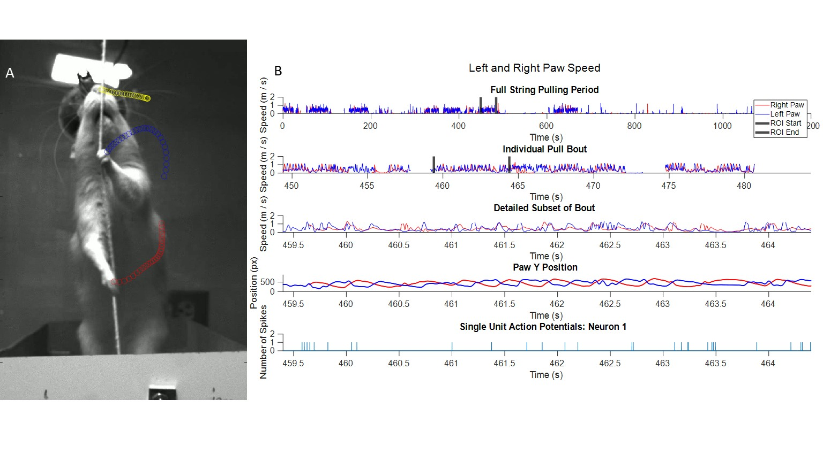

|  |  |  |
| --- | --- | --- |
| **Table 1 - Parts List** |  |  |
| **Component** | **Company** | **Website** |
| **Camera** |  |  |
| Mako U130b Camera* | Allied vision | https://www.alliedvision.com/en/products/featured-products/ultra-compact-mako-machine-vision-cameras-with-ptp-and-toe.html |
| LED Panel | Viltrox | https://www.amazon.com/VILTROX-L116T-3300K-5600K-Temperature-Brightness/dp/B07D8TTFSR/ref=sr_1_3?dchild=1&keywords=viltrox+led&qid=1620409459&sr=8-3 |
| Ring Light | UBeeSize | https://www.amazon.com/10-Extendable-UBeesize-Ringlight-Compatible/dp/B07QFV72LK/ref=sr_1_3?dchild=1&keywords=ubeesize+ring+light&qid=1620409432&sr=8-3 |
| **Arduino** |  |  |
| Arduino Mega | Arduino | https://store.arduino.cc/usa/mega-2560-r3 |
| Rotary Encoder | BQLZR | <https://www.amazon.com/gp/product/B00UTIFCVA/ref=ppx_yo_dt_b_search_asin_title?ie=UTF8&psc=1> |
| Solenoid Feeder | STC Valve | https://www.stcvalve.com/Solenoid-Valve-Specifications-2P025-Series.htm |
| **Frame** |  |  |
| 90° Joints | LANIAKEA | https://www.amazon.com/gp/product/B08NXGV1YH/ref=ppx_yo_dt_b_search_asin_title?ie=UTF8&psc=1 |
| Extruded Aluminum | Zyltech | <https://www.amazon.com/gp/product/B07F6R2Z99/ref=ppx_yo_dt_b_search_asin_title?ie=UTF8&psc=1> |
| **Intan** |  |  |
| Intan USB Interface Board | Intan Technologies | https://intantech.com/RHD_USB_interface_board.html |
| **Video Recording Computer** |  |  |
| RAM | G.Skill | https://www.amazon.com/dp/B08175L812?tag=pcpapi-20&linkCode=ogi&th=1&psc=1 |
| SSD | Western Digital | https://www.amazon.com/WD-Blue-500GB-SSD-WDS500G1B0B/dp/B01LXPD2WB |
| *\*Specific Model Discontinued* |  |  |

# **2. Material and Methods**

## **2.1 System Design**

The behavioral quantification system is composed of a high speed camera (up to 367 fps) and rotary encoder connected to a solenoid liquid dispenser (STC Valve, Silicon Valley, California, United States) and a loop of string positioned around a series of pulleys that can continue rotating indefinitely without being manually reset The overall system layout is given in **Figure 3A** and the components to build the system are listed in **Table 1**. This “infinite pulley system” can allow for longer continuous pulls and variable target distances within a session; individual pulls up to 16 meters were observed. Both subsystems are connected to the neural recording system and synchronized through Transistor-Transistor Logic (TTL) pulses delivered by the camera and Arduino microcontroller. These components are controlled through Matlab and Arduino code, and also contain two circuits. Inputs from these components to the neural recording system allowed quantified behavior to be synchronized with neural activity. The data preprocessing steps before analysis are outlined in **Figure 3B**.

A

B



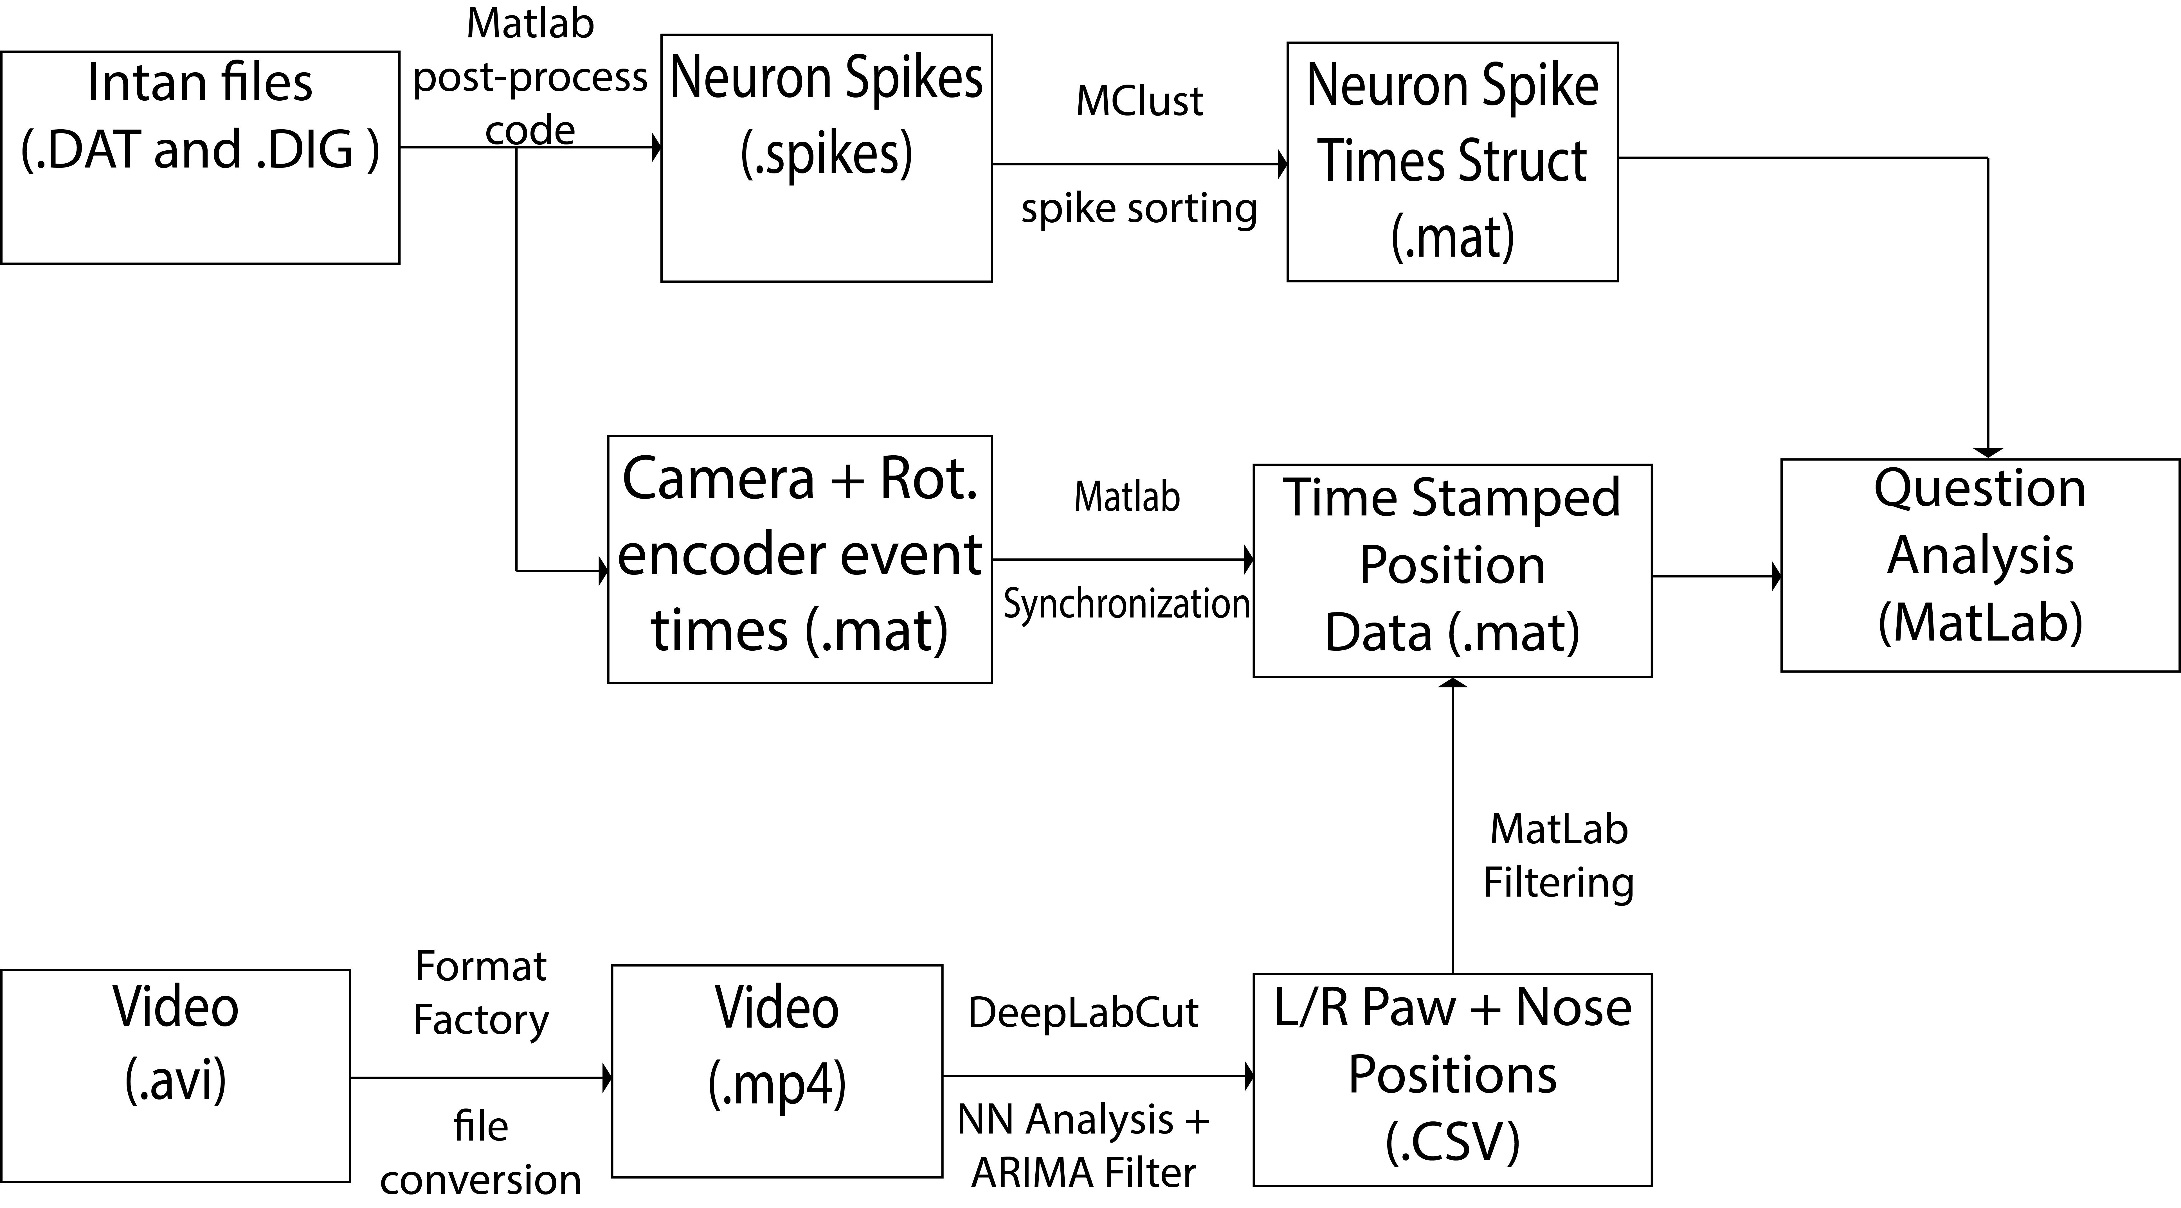

**Figure 3**: **A)** Behavioral Quantification System Diagram. A high speed camera and Arduino with rotary encoder/reward dispenser inputs/outputs are set up to control and record the string pulling behavior. The camera and Arduino subsystems are configured to send TTL pulses to the INTAN board periodically to align behavior activity with neural activity. **B)** Pre-processing pipeline of collected data. Intan neural data (.DAT) and digital input data (.DIG) are processed separately from the video data (.AVI) by various programs before being combined for analysis.

### **2.1.1 Video Camera**

Videos were captured from a MakoU130b camera (Allied Vision, Stadtroda, Germany) configured with the Image Acquisition Toolbox in Matlab2019b. MakoU130b cameras have a high frame rate (367 fps) that reduces motion blur in fast-moving subjects in video. Overhead lighting was provided by a programmable LED panel (VILTROX, China) and forward lighting was provided by a ring light (UBeeSize, City of Industry, California, United States) placed around the camera lens. The camera and ring light were secured to an extruded aluminum arm by a custom 3D printed mount. This arm was connected to the string pulling platform so that the camera orientation and distance from the pulling platform remained consistent between recording sessions. The Matlab Image Acquisition Toolbox Graphical User Interface (GUI) and a second circuit were used to configure the camera to send a TTL pulse to the Intan data acquisition system (Intan Technologies, Los Angeles, California, United States) every time a frame was exposed. This allowed the timing of each frame to be aligned with the recorded neural activity. This circuit consisted of an open collector trigger from the camera and a pull up resistor to process the signal for triggering the Intan system. After collection, video information was processed by DeepLabCut (Mathis et al., 2018) and custom Matlab code (github.com/GiaJordan/Behavior_Quantification).

### **2.1.2 Rotary Encoder**

String Pulling data was collected with an Arduino MEGA (Arduino, Somerville, Massachusetts, United States) and a 600-pin rotary encoder (BQLZR, Shenzhen, China). A food reward dispenser was also connected. Matlab software was used to process the data after collection. The rotary encoder was incorporated into an infinite-pulley system with a 3D printed wheel and stand whose drawings and STL files are available on Github. The frame of the pulley system was composed of extruded aluminum rods joined with 90° screw joints (LANIAKEA). Wheels and bearings for the string, along with mounts for the camera and lighting were fixed onto the frame with 90° joints and 3D printed parts. The rat performed the behavior on a wooden platform attached to a stand composed of extruded aluminum (Zyltech Houston, Texas, United States). The string passed through the middle of the platform at one end to allow for easy pulling by the rat.

Having an infinite loop of string allows the rat to be trained to pull for longer distances than with traditional pre-cut strings, and a reward can be dispensed automatically at a given distance through the inclusion of the rotary encoder and software. The software allows for users to define an array of target distances to be reached over a session. The capacity to precisely adjust target distances can streamline training and behavior administartion. For example, short distances can be rewarded initially and then gradually and automatically increased as performance improves. Reward delivery can also be manually triggered by the experimenter through an attached button. By inputting an array of target distances where rewards are dispensed, the rat’s behavior can be reinforced with minimal human input.

The string is wrapped around a rotary encoder which detects 1/600th of a full rotation (one tic). In practice, this sensitivity combined with the speed of the string reached when the rats pulled at a high rate was too fast for the data acquisition system to track reliably. Consequently, a custom circuit and software were added to send a TTL pulse to the Intan recording system when only a portion of tics were detected (every 30 ticks or 0.3432cm). The timing of these pulses was synchronized to when the rat pulled the string for the given length, and the inter-pulse interval allowed us to determine the speed the rats were pulling the string at that time. Since this timestamp information was recorded through the INTAN system (Intan Technologies, Los Angeles, California, United States), string pulling metrics could then be aligned to the neural activity and paw position data that was collected concurrently. Most components of this device, with the exception of the rotary encoder, can be placed outside of the Faraday cage to limit electrical noise that could contaminate the neural recording signal. In our tests, the string-pulling system produced no observable electrical artifacts in the collected neural data.

### **2.1.3 Behavior Metric Synchronization with Neural Activity**

Electrophysiological signals were acquired from the primary motor cortex (M1) and striatum (STR) regions using the Intan acquisition system. The Intan system contains 16 Digital I/O pins, and pins 12 and 15 were used to receive TTL pulses from the recording camera and Arduino board that were used to track behavior. Pins for the button and feeder were located on the Arduino. Voltage dividers reduced the voltage of digital inputs to the Intan system to 3.1-3.3 V. TTL pulses were sent to the Intan interface board whenever the camera exposed a frame and every 1/20th of a full rotary encoder rotation, which is equivalent to every 30 ticks or 0.3432cm. The timestamps from the camera were aligned to the position comma separated value (CSV) coordinates output by DeepLabCut in Matlab.

### **2.1.4 Motion Tracking with DeepLabCut**

A deconvolutional neural network (DeepLabCut, (Mathis et al., 2018)) was first trained on 108 manually-scored images (training frames) to identify rat paws and nose during string pulling behavior. A human scorer identified the location of the nose and each paw for each training frame and the network then used this information to improve the estimation of feature position. The network was subsequently trained for 730,000 iterations using the labeled video frames on a 85:15 train:test split until the loss converged at 0.003. Labeled images were taken from 3 session videos and 1 rat.

Accuracy of the neural network was verified by labeled test images after training. Analysis with the network produces CSV files containing the x and y positions of each tracked item as well as a confidence measure (0.0-1.0 – which roughly translates to a likelihood I believe, right?) of the prediction for each frame. The first round of filtering was an autoregressive integrated moving average (ARIMA) filter within DeepLabCut that was applied to the data with degrees AR=3 and MA=1. TTL pulse timestamps for each frame were added to the CSV and the coordinates were filtered further with Matlab. In Matlab, any coordinates with confidence values below 0.5 or that lay more than 10 pixels (0.26 cm) outside a moving average of the previous 10 frames were discarded. Short ranges (<30 frames) of missing values were estimated via piecewise cubic interpolation (pchip) between acceptable values and reincorporated. The segments of good values were low pass filtered where frequencies greater than 12 Hz were removed from the series. Short ranges of good values (<184 frames) were discarded so that only more stable and accurate segments remained. Frames where paw speed was uncharacteristically high (>130 cm/s) were also excluded from the series. The remaining values were used to track position and calculate movement dynamics. Time stamps from camera pulses were aligned and added to the position coordinates for each frame to be used in further analysis.

### **2.1.5 Behavioral Segmentation**

Using the filtered paw coordinates produced by Matlab code, the reach and withdraw phases of individual pulls were identified. The reach phase is defined as “upward forelimb movement without string contact”, while the withdraw phase is defined by “downward movement that included string contact” (Blackwell, Köppen, et al., 2018). Periods of sustained positive velocity in the y direction were used to identify when the rats were raising a paw, and periods of sustained negative velocity in the y direction identified when a paw was lowered. After segmenting pulls into reach and withdraw phases, each phase was further divided into the Lift, Advance, Grasp, Pull, and Push segments as identified in literature (Blackwell, Köppen, et al., 2018). Segmentation accuracy was determined visually; videos of each segment were created, and movements of the entire arm were compared to the hallmarks of each segment as described in literature (Blackwell, Köppen, et al., 2018). **Figure 4** shows the trajectories of the reach and withdraw phases of a control and lesioned animal with segments identified by color.

Segment start and end points were identified using paw coordinates and velocities as well. Lift, Advance, and Grasp segments were segmented from periods of upward motion previously identified. The lift segment began at the start of upward motion and ended when the paw reached its maximum x coordinate away from the center of the body. At this point, the advance segment began. This segment is characterized by the “raising of the upper arm at the shoulder with a slight adduct

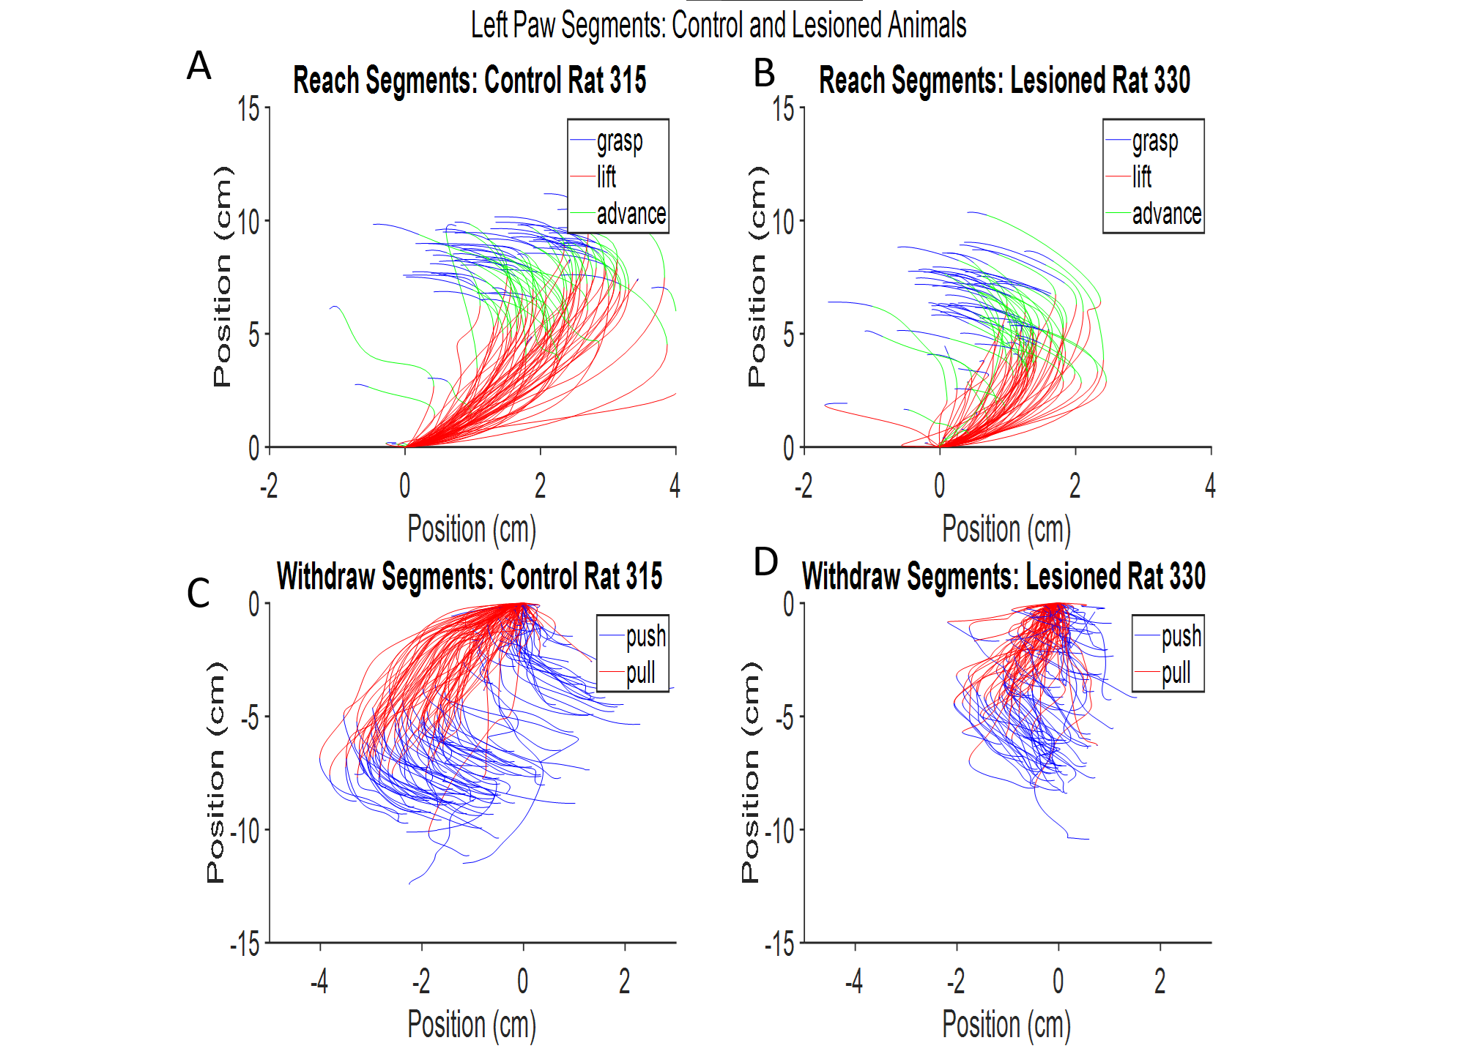

**Figure 4:** Left paw trajectories for the Left paw of a control animal (**A&C**) and a hemi-lesioned PD model animal with a right hemisphere lesion (**B&D**) over the reach (**A&B**) and withdraw (**C&D**) phases of pulling from a single session. Reach and withdraw phases are subdivided into 5 segments identified by color. Segment start and end points were determined by looking at the paw speeds in the x and y directions along with the horizontal paw position over the period of the appropriate phase. The paths of the lesioned animal’s affected paw appear to be shorter in both phases, and have less range in the x direction as well.

movement” followed by an “extension of the lower arm.” After the advance phase ends, the grasp begins. The beginning of the grasp segment is characterized by medial movement of the arm with respect to the body. The transition point from advance to grasp was defined as the point when the velocity in the y direction is 0.5 standard deviations less than the mean velocity from the end of lift to the end of the upward motion.

Pull and Push segments were identified from the downward motion previously separated. The Pull segment began when downward motion began and is characterized by the upper arm being lowered slightly at the shoulder and the lower arm being flexed by closing at the elbow. The end point, which is “at about the middle of the chest, the rat’s center of mass” was identified in coordinates as the peak x coordinate away from the rat’s center of body. Videos were used to verify that this point corresponded to the center of the rat’s chest. The Push segment was the remaining portion of the identified downward motion and is characterized by “the upper arm [continuing] to be lowered and the lower arm [extending] by opening at the elbow.”

The beginnings and ends of each segment were identified by video frame number and from this point, segments could be studied individually along with single unit and ensemble activity and yield kinematic information for each paw such as speed, peak speed, Euclidean distance traveled, total distance traveled, elapsed time, and path circuity (Blackwell, Widick, et al., 2018) specific to each segment of a pulling cycle.

## **2.2 Animals**

Male, Sprague-Dawley rats (*n*=2, ~275-350 g at time of arrival; Envigo RMC Inc., Indianapolis, IN) were single housed in a temperature and humidity-controlled room on a 12-hr reverse light/dark cycle. Food and water were provided *ad libitum* for the duration of the habituation period. When training began the rats were food restricted to 85% of their body weight. All animal procedures were done in accordance with NIH guidelines for the Care and Use of Laboratory Animals and approved by the Institutional Animal Care and Use Committee (IACUC) at The University of Arizona.

## **2.3 Stereotaxic Surgeries**

Anesthesia for each surgical procedure was administered by isoflurane (1.5-2.0%; VetOne, Boise, ID, United States) mixed in a vaporizer (JD Medical, Phoenix, AZ, United States) with 1.5 L of oxygen per minute.

Naïve - Rat 315

Behavioral and neural measurements were obtained from a naïve rat (421 grams upon implantation) implanted with a dual-bundle microdrive containing 16 independently-adjustable tetrode recording probes targeting the primary motor cortex (M1) and striatum (STR) of both hemispheres of the brain at anterior-posterior (AP) 1.5 and medial-lateral (ML) 2.1. Tetrodes were constructed of Polyamide-insulated Nickel Chromium Steel wire with a diameter of 12-13 µm and were driven to an initial depth of 200 µm at surgery. Tetrodes were lowered to record extracellular spikes from M1 neurons and later from STR neurons. Two additional tetrodes whose wires had been shorted together acted as ground. A ground screw and all wires were secured to the skull using dental acrylic.

6-OHDA - Rat 330

Behavioral measurements were obtained from a 6-hydroxydopamine hydrochloride (6-OHDA) lesion model of PD. The surgical procedure was based on that previously described in the literature (Bartlett et al., 2016), unless noted below. Rat 330 (315 grams at surgery) was pretreated with desipramine hydrochloride (12.5mg/kg; Sigma-Aldrich, St. Louis, Missouri, United States) administered intraperitoneally (*i.p.*) 30 minutes prior to 6-OHDA injection to prevent damage to noradrenergic neurons. The rat was then given two unilateral microinjections of 6-OHDA (5.0µg/µl in 0.9% sterile saline with 0.02% ascorbic acid) in the medial forebrain bundle (MFB): AP = -1.8 mm, ML= +2.0 mm, DV= -8.2 mm, and AP = -2.8 mm, ML= +1.8 mm, DV = -8.2 mm. A volume of 2.5 µL of 6-OHDA was microinjected at each site (12.5 µg/coordinate) for a total of 25 µg at a rate of 0.5µl per minute using a Stoelting microinjector (Stoelting Co., Wood Dale Illinois, United States). Three weeks following 6-OHDA administration, the severity of the lesion was assessed using the amphetamine-induced rotation test. Dextro-amphetamine (5 mg/kg in sterile 0.9% normal saline, *i.p.*; Sigma-Aldrich) was injected and the rat was placed in a plexiglass cylinder (22.8 cm diameter x 30.6 cm height). The mean (6.11) net ipsilateral rotations per minute were counted as previously established (Bartlett et al., 2016). In our laboratory, ≥4 ipsilateral rotations per minute correlates to a greater than 90% loss of dopaminergic neurons. hydroxy-dopamine

## **2.4 Animal Training**

The rats were handled for 30 minute increments over a period of 1-2 weeks to become accustomed to the experimenters. At the onset of training, the rats were food-restricted according to the IACUC guidelines. The rats were weighed after each training session. Food was provided to keep the animals above 85% of their free-feeding weight. String pulling training was based off of previously published string pulling literature (Blackwell, Köppen, et al., 2018).

The animals were trained in the string pulling behavior in incremental steps. Animals were initially habituated in a walled arena with 20 strings of lengths 30-100 cm draped over the edge. Half of these strings were baited with a Cheerio. The rats were allowed to interact with and pull the string to receive the reward. Initially animals were encouraged to pull by receiving a half Cheerio reward for a partial pull of the string. The rats were left in the arena for one hour or until all strings had been pulled completely inside. After which, the rats were removed from the training area and placed back in their home cage. This continued for two sessions. If necessary, the rat received an additional habituation day if performance on the infinite loop was unsatisfactory, as described later. This concluded the habituation phase.

To begin training, the rats were trained on single 1 meter, 2 meter, and 3 meter strings in the arena until they pulled each length 3-4 times. Cheerios at this stage were manually given upon completion of pulling the entire string. The rats were then trained on an infinite-pulley system and would receive a half or quarter cheerio reward after a bout: a period of sustained pulling. This training was done on a raised platform without walls. The rats were encouraged to pull for longer bouts by gradually restricting rewards for shorter bouts. The maximum distance pulled in a single pulling bout for rat 315 during the first 14 days of training after habituation is illustrated in **Figure 5**. The switch from using single strings to the infinite loop system occurred between days 3 and 4. Using the infinite loop instead of precut strings allowed us to better understand the limits of how far the rats were willing to pull, as they could pull indefinitely. During its 60 minute sessions, rat 315 pulled a total of 0.5 meters on the first day of training, a total of 431 meters on day 14, and had the highest total distance during the first 14 days of training on day 12 with 713 meters pulled. Initially, if the rats were unwilling to interact with the string in this system, they received an additional training session in the original cage and setup. Pulling sessions continued for one hour periods or until prolonged (>10 min) periods of no string-pulling activity.

**Figure 5:** Maximum distance pulled in meters by rat 315 on each of the first 14 days of training following the initial habituation. The switch from single strings to the infinite loop occurred between training days 3 and 4 and is denoted by the vertical black bar.

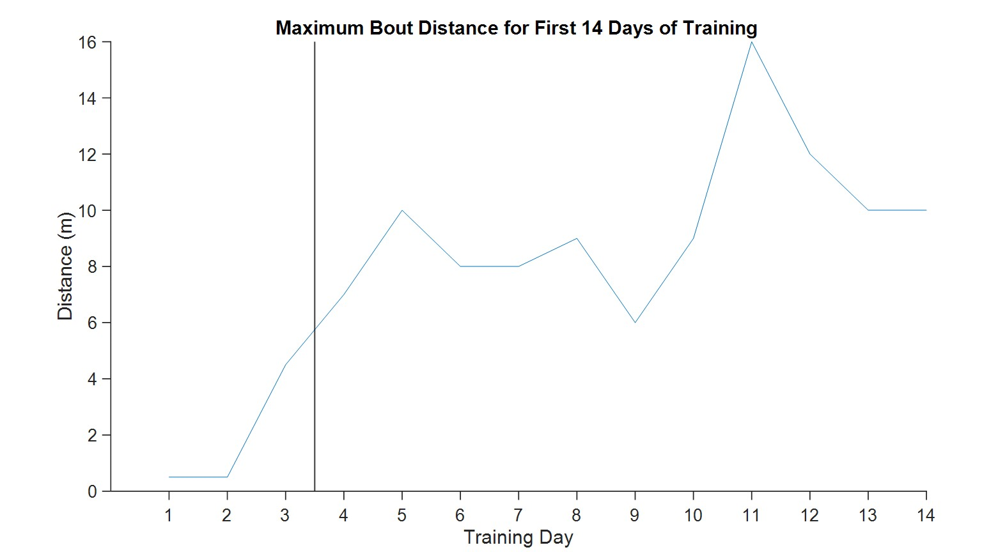

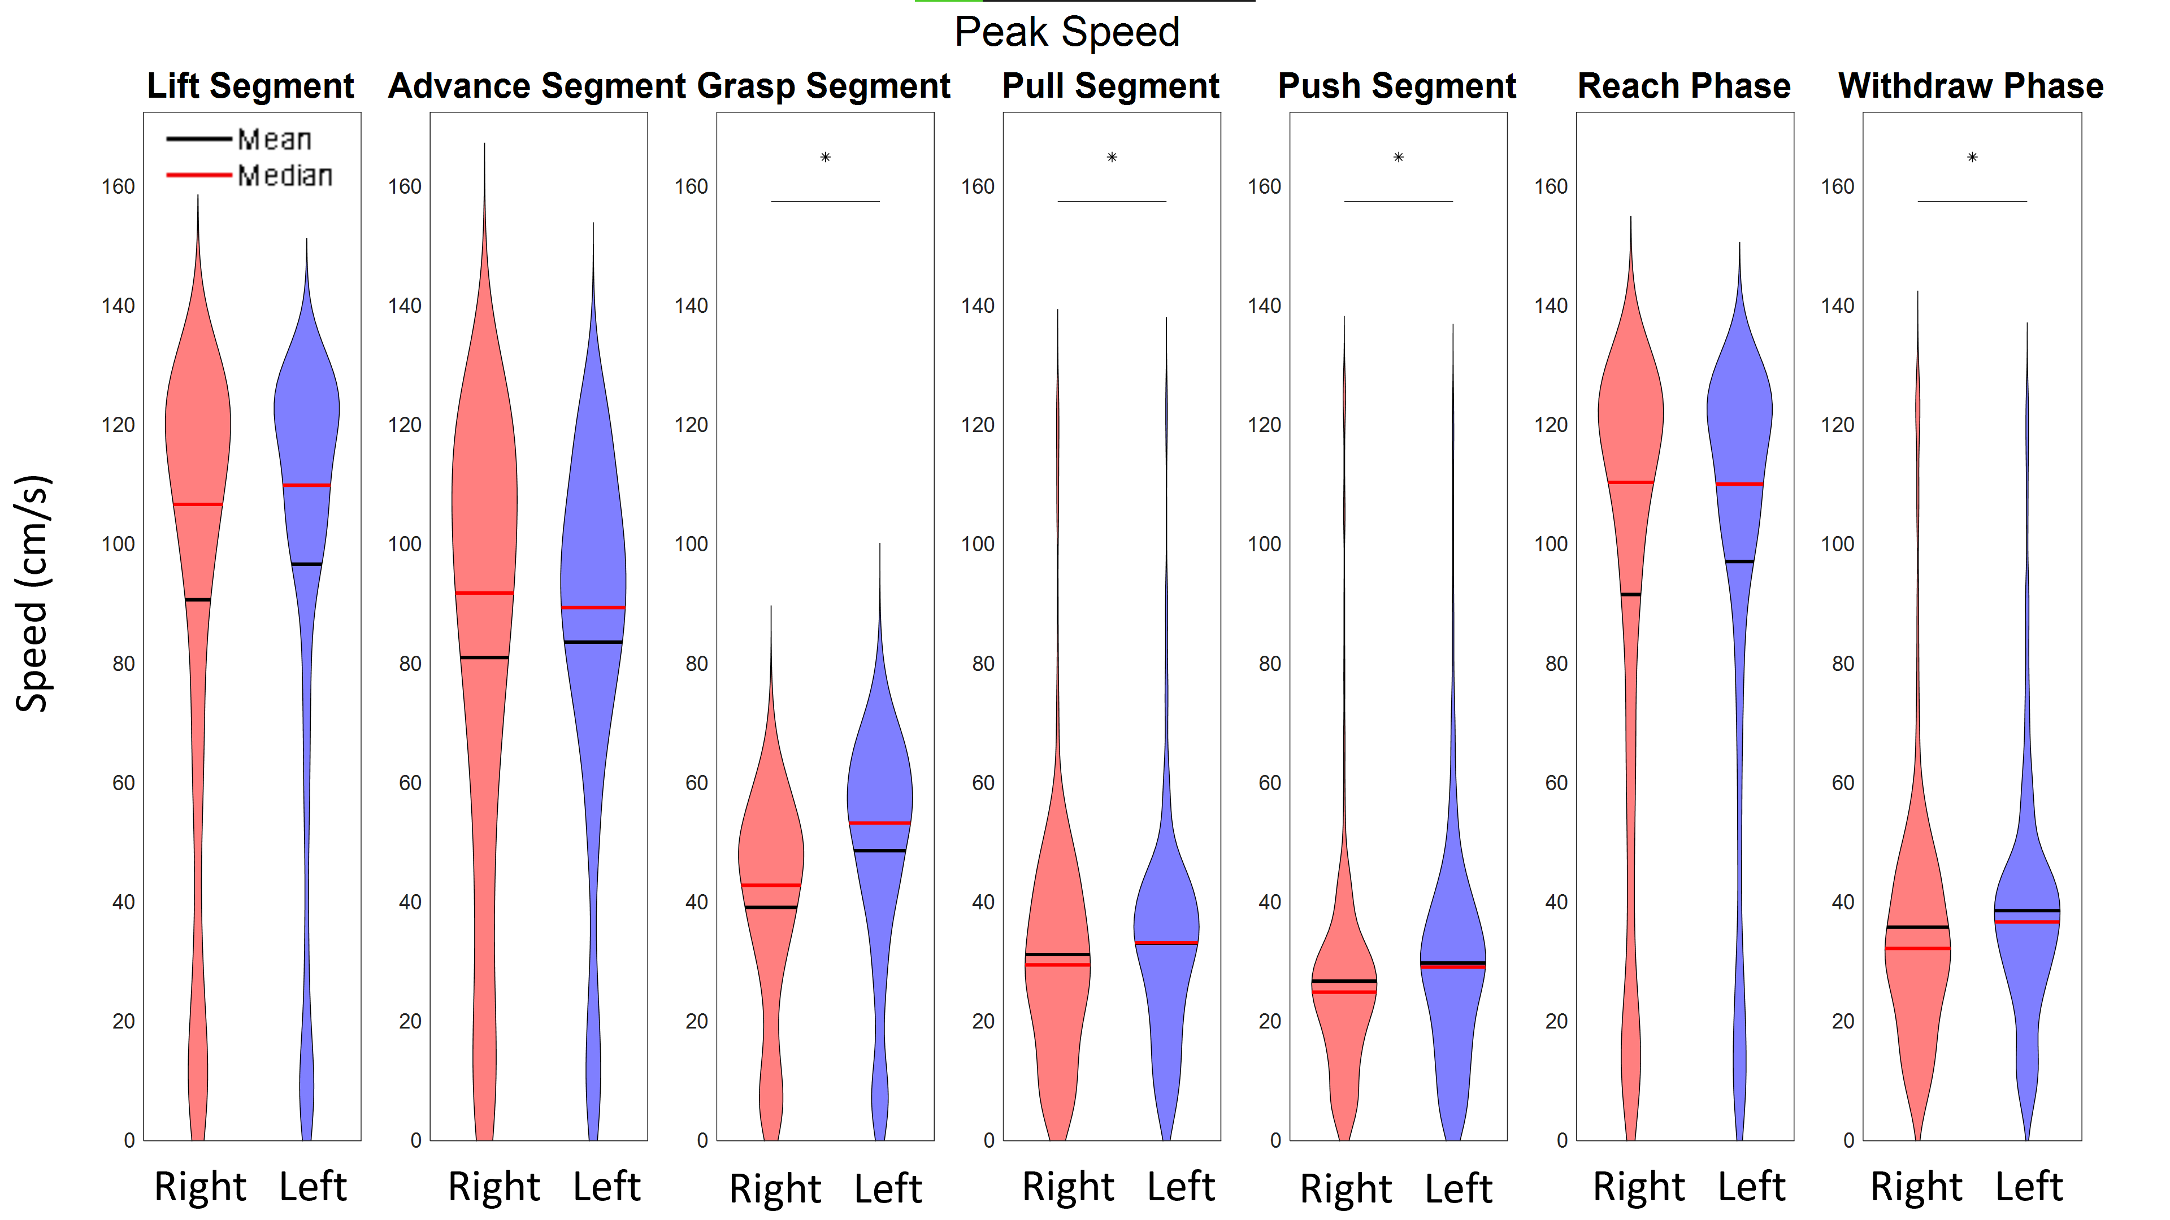

**Figure 6:** Peak speed distributions of the left and right paw of a hemi-lesioned PD model animal with a right hemisphere lesion for each segment and phase over a single session. Lines and stars indicate statistically significant differences (p<0.05) in the distributions of peak speeds of the left and right paws. Though we expected the peak speeds of the limb with the deficit to be lower, the left paw has similar, or faster distributions of peak speeds when compared to the right paw. This session was the 3rd session after the 6-OHDA lesion, so it is likely that while the lesion was at full effect the rat may have still been very motivated to pull. It is also possible that this rat had a preferred, or dominant paw that is more efficient at completing pulls in this task.

**2.5 Data Analysis**

All post-processing, filtering, and statistical analyses were performed using Matlab2019b and Python 3.6.

# **3. Results**

## **3.1 Validation of Motion Tracking**

DeepLabCut provides validation metrics such as distance in pixels of the estimated feature positions from the manually labeled positions. Analyses of these data showed a 1.04 pixel (~0.027 cm) error for the training split images and a 4.33 pixel (~0.105 cm) error for the test images. For our video recording configuration, rat paws were found to have widths (~35 px or ~0.92 cm), which was approximately 9-fold wider than our test error (4.33 px or ~0.105 cm). Given the difference between the paw width and the detection error of the network, we find this level of tracking accuracy acceptable.

## **3.2 Paw Kinematics**

Our method of behavior tracking and quantification also yields paw kinematic information similar to those provided with existing methods (Blackwell, Köppen, et al., 2018; Inayat et al., 2020). Measures such as average speed, peak speed, total distance traveled, displacement, elapsed time, and path circuity can be calculated easily from the time stamped paw coordinates. Violin plots of the peak paw speeds over each segment and phase for a lesioned animal are presented in **Figure 6**. These metrics can be studied on a segment level as well as over an entire reach or withdraw phase. The segment-by-segment analysis is also useful for revealing differences between paws that may arise from certain motor disorders or injuries and identifying where in the pulling cycle the deficit is the greatest. For the session presented in **Figure 6**, the left paw had similar or faster peak speeds when compared to the right paw. This rat had a right hemisphere 6-OHDA lesion. The faster left paw speeds in **Figure 6** could be because that paw may be preferred by the rat for activity in this task, or because the rat was still motivated enough to pull vigorously despite the lesion.

**Figure 7:** Motor cortex single unit response to pull phase (**A**) and right paw position (**B**). **A)** Over the course of a session, the identified neuron fires more during the withdraw phase of the right paw than the reach. The position of the paw when this neuron fired is denoted with blue circles. **B)** Other neurons also have preferential firing locations for the right paw. These heat maps show firing rates of 4 M1 neurons over the course of a session for different locations of the right paw and have been normalized for paw occupancy.

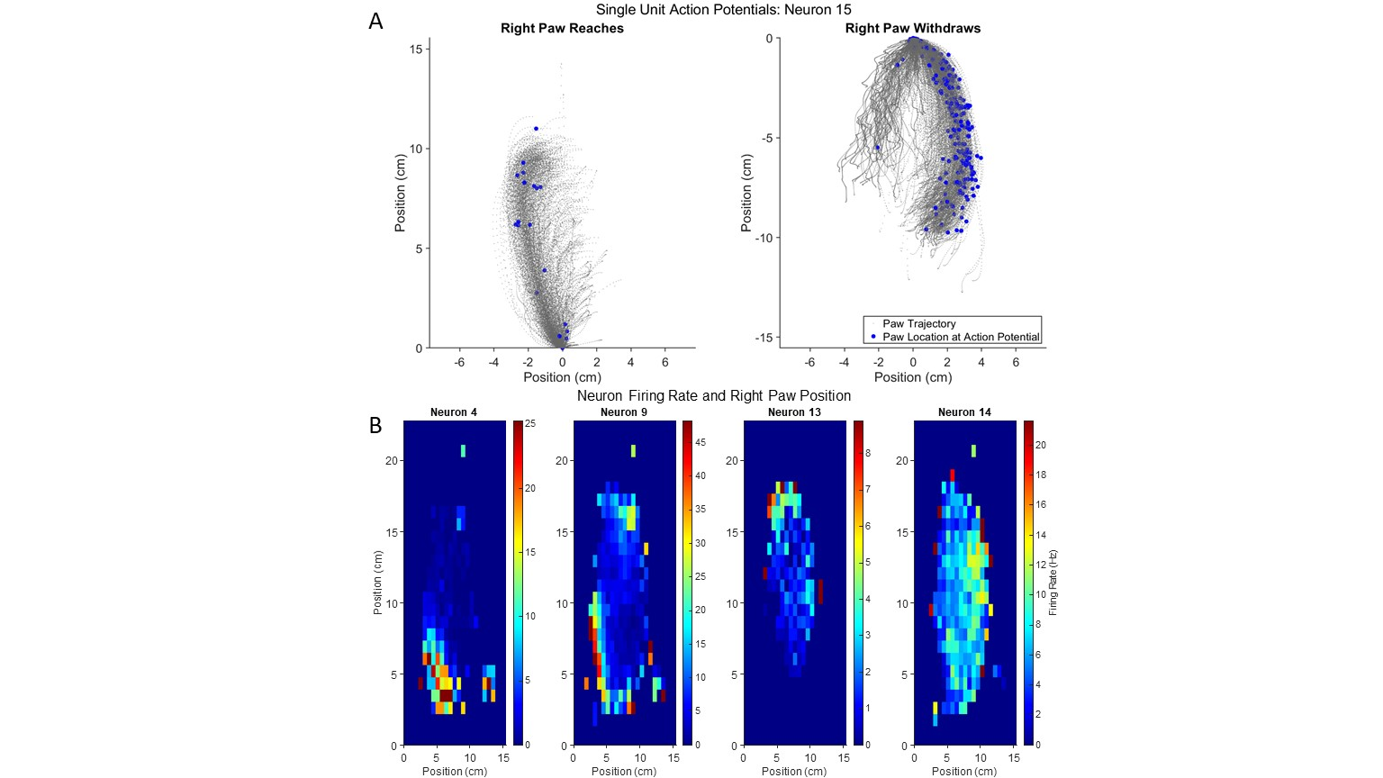

## **3.3 Single Units with Preferential Firing**

Motor cortex neuron activity at the single unit level was analyzed in relation to phase of pulling, pulling segment onset or offset, and raw paw or nose location. Examples of neurons identified to have preferential firing in relation to pulling phase and paw position are presented in **Figure 7**, and an example of a single unit with modulated firing around the start of a pulling segment is presented in **Figure 8**. Preferred firing phase was determined by performing a Wilcoxon rank sum test on the distributions of firing rates for each phase. Phases with significantly higher firing rate distributions (p<0.05) were considered preferred.

Some neurons were found to prefer to fire in either the reach or withdraw phases. **Figure 7A** shows all of the reach and withdraw trajectories for one rat from a single session; paw positions at the times of action potentials of one neuron are denoted as blue circles. Other neurons were found to increase their firing when a paw was at a certain position. To investigate this, the camera field of view was binned in x and y directions and the occupancy of each extremity in each bin was calculated from the position data. Paw positions at neuron firing times were obtained by interpolation. The firing rate of 4 motor cortex neurons from one session for different positions of the rat’s right paw are given in **Figure 7B**. Some neurons (4 and 9) increase their firing when the right paw is in the lower left corner of the video frame, the position the right paw typically occupies after completing a downward pull motion. Neuron 13 fires the most when the paw is in the upper portion of the frame, typically when the rat is moving to begin another downward pull. Neuron 14 has the highest firing rate when the right paw is towards the center right of the frame, where paw normally occupies during the downward motion. Some neurons were found to have modulated firing in the 500 milliseconds before or after the onset of a segment or the offset of a phase. One such neuron that was found to modulate its firing before and after the onset of the push segment is shown in the raster and peri-event time histogram in **Figure 8A and B**. This neuron appears to be responding to changes in the left paw’s vertical position, which is plotted in **Figure 8C**. Over all sessions, the proportions of single units with firing rates significantly different between phases are shown in **Figure 9**.

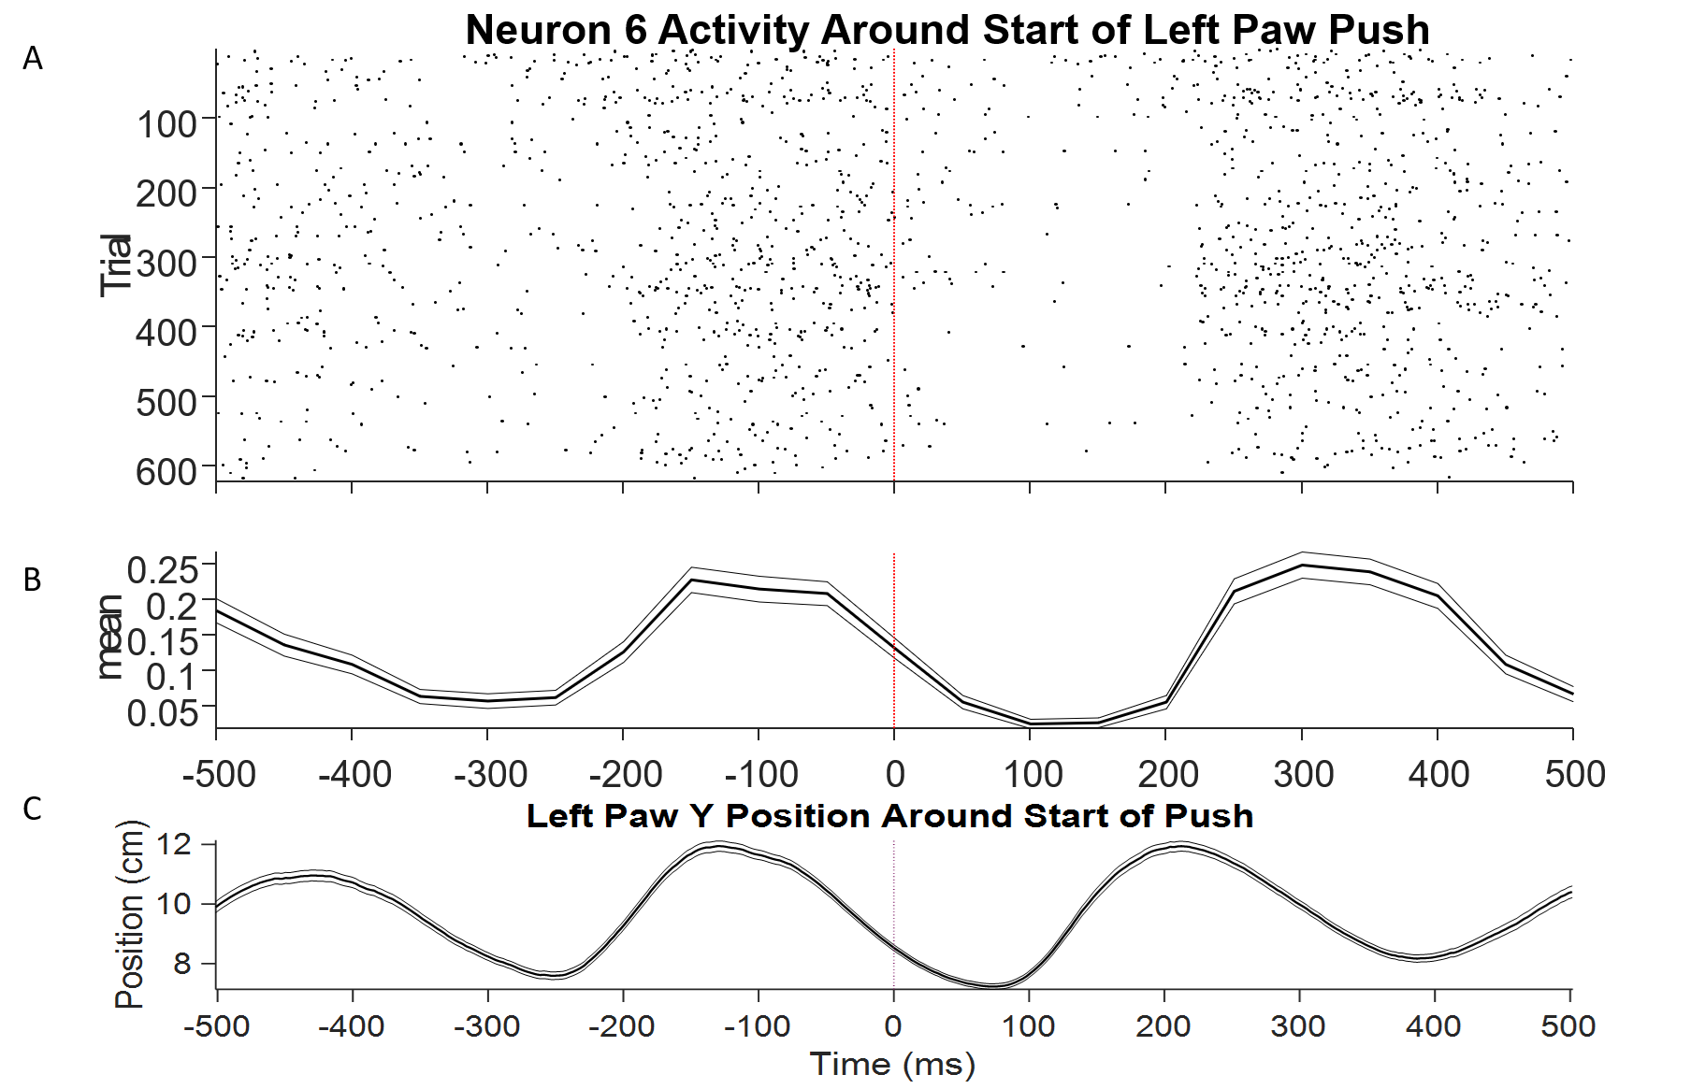

**Figure 8:** Individual action potentials (A) and mean firing rate (B) of neuron 6 (motor cortex) of a naïve animal in the 500ms before and after the start of every identified “push” segment of the left paw. Data comes from one session of string pulling. Neuron 6 appears to modulate its firing according to the vertical location (C) of the left paw near (±150ms) the onset of the push segment.

# **4. Discussion**

## **4.1 General Discussion**

The described system allows automated control and quantification of behavior in the bimanual string pulling task and allows these measures to be synchronized with single unit neural activity in rodents. While useful for data collection, our system also permits the automated shaping of animals in this task through the ability to set variable target pull distances. Our incorporation of an infinite loop of string also allows for longer individual pull distances and more pull trials over a session. For example, an individual pull of 16 meters was observed during training and on one day a rat pulled a total of 713 meters in an hour. We have been able to record the position, velocity, and acceleration of a rat’s paws during the task at a high temporal resolution while simultaneously recording single unit neural activity. The motion tracking capabilities were validated with prediction pixel error relative to paw size and videos labeled with paw extremity positions after data filtering. The system relies on easily constructed or purchased components (**Table 1**) and publicly available code.

**Figure 9:** Proportions of all single units from both the motor cortex and striatum with firing rates significantly modulated by phase.

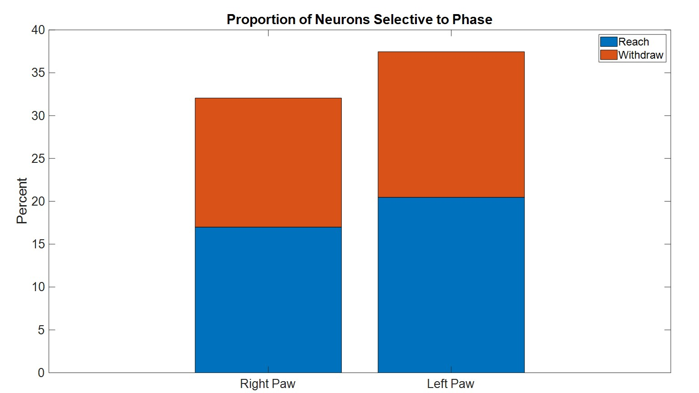

We were able to identify neurons whose activity was modulated during components of the string pulling task such as phase (**Figure 7A**) as well as identify neurons that had modulated firing around the start or end of the identified pull cycle segments (**Figure 8**). We were also able to identify neurons that had preferred firing locations for different extremities (**Figure 7B**).

This system yields many of the same paw kinematics described in other published methods for studying string pulling in rodents such as average speed, peak speed, total distance traveled, displacement, elapsed time, and path circuity on a segment-by-segment basis (Blackwell, Widick, et al., 2018; Inayat et al., 2020). In addition, our system provides the added benefits of using open source and reproducible tools and being compatible with neural recording systems.

## **4.2 Applications**

The proposed system is useful in behavior analysis during the string pulling task as it results in more movement information along with synchronized neural information. Behavioral performance between animals and movement differences between paws can be easily identified and quantified with our system. Paw location, speed, and acceleration can all be analyzed alongside neural activity to identify sets of neurons that respond to different components of the task. Paw kinematics and neural responses specific to individual segments or phases of the pull cycle can also be studied. This can be useful for future studies seeking to identify the neural states involved with reaching behavior or motor control in general. Implanting animals with dual hemisphere drives targeting the motor cortex of both hemispheres would allow for much more detailed study of how individual neurons and neural ensembles are involved in bimanual movements.

Previous studies have explored the effects of unilateral forelimb sensorimotor cortex devascularization on rodent performance in the string pulling task (Blackwell, Widick, et al., 2018). The authors note that prior to their investigation, “there [had] been no investigation of the contribution of rodent motor cortex to an intrinsically, coordinated bilateral motor act such as string pulling.” Our proposed system would allow for a more detailed investigation of the role of the motor cortex in complex motor activity. Along with changes in pulling behavior, neural activity from each hemisphere of the motor cortex can be studied and differences between lesioned and control animals can be investigated on a segment-by-segment basis. Such application would reveal how the motor cortex organizes its activity to produce movement and how that organization is changed in a lesioned state. This level of analysis may also be desired for studies assessing other neurological injuries or motor disorders.

Some of our ongoing efforts include utilizing a hemi-lesioned 6-OHDA lesion rodent model of PD in the string pulling task. In the future, we plan to compare lesioned animals’ performance to that of controls and also obtain electrophysiological recordings from lesioned animals for analysis.

## **4.3 Future Implementations**

Certain variations could improve upon the effectiveness of the behavioral quantification system. DeepLabCut allows for tracking in 3 dimensions with the addition of one or more cameras. Adding cameras and training a new network would likely improve segmentation of the string pulling behavior and reduce lost data due to occlusion.

Variations could also be made on the string pulling behavior. For instance, varying the angle of the string enough to require new pulling motions could allow for a new subset of neurons that respond to the kinematics of the new motion or position of the paws to be investigated. Learning could also be studied by gradually changing the string angle of pulling from vertical to horizontal. A horizontal string pulling configuration would introduce a new motion and introduce the element of choice, as the rat could pull the string in either direction. The addition of a second string or levers to the existing setup could allow for the study of decision making or the remapping of place fields as well.

Connecting an automatic feeder that dispenses a reward at a set pull length would condition the rat to expect a reward at that pull distance. Varying the frequency of these rewards would allow for the investigation of reward expectation and the rat’s response to receiving or being denied an expected reward. With variations of the required behavior or reward conditions, the same system can be used and more information can be gained with relatively few design changes.

## **4.4 Limitations**

There are limitations to this system in its current form that will have to be addressed by those wishing to utilize it, specifically the hardware required. Neural networks require significant computer resources to train, and without a Graphical Processing Unit (GPU), network training times can be prohibitively long. While physical GPUs may be difficult to obtain and configure for some researchers, services like Google Colaboratory (Google, Mountain View, California, United States) give scientists access to GPUs through online notebooks that are also compatible with DeepLabCut. For this specific task, a high frame rate camera was needed to avoid motion blur and allow the neural network to recognize each paw. Lower frame rate cameras, while cheaper, will produce less than optimal results in this regard when recording fast-moving animals such as rats.

Finally, while our system allows for the inclusion of neural information in analysis and detailed information about paw movements, fewer metrics for the rest of the body are available when compared to other methods (Inayat et al., 2020).

# **5. Conclusion**

Our behavioral quantification system was constructed with easy to obtain components (**Table 1**) to aid in accessibility. Video recording is controlled by a Matlab GUI, and a rotary encoder-Arduino combination was used to quantify string pulling. A deconvolutional neural network from an open-source code base was utilized for markerless motion tracking. The code is available on GitHub and is easily adaptable to the needs of other research teams. The camera and rotary encoder subsystems can be used with any neural recording system that has general purpose I/O pins so that timing information can be obtained as well. Circuits of these subsystems only require soldering of a few components and can be done by those with limited soldering experience.

Together, these components make a system capable of quantifying various features of the string pulling task and aligning this data with neural activity. The measures yielded from this system are similar to others developed for the string pulling task and are able to be obtained while recording neural activity as well. Our system not only allows for the automated shaping of animals in the string pulling task and automatic segmentation of complex motions, it is easily adaptable for a variety of current and future endeavors as well.

# **References**

Allred, R. P., Adkins, D. A. L., Woodlee, M. T., Husbands, L. C., Maldonado, M. A., Kane, J. R., Schallert, T., & Jones, T. A. (2008). The Vermicelli Handling Test: A simple quantitative measure of dexterous forepaw function in rats. *Journal of Neuroscience Methods*, *170*(2), 229–244. https://doi.org/10.1016/j.jneumeth.2008.01.015

Bartlett, M. J., Joseph, R. M., LePoidevin, L. M., Parent, K. L., Laude, N. D., Lazarus, L. B., Heien, M. L., Estevez, M., Sherman, S. J., & Falk, T. (2016). Long-term effect of sub-anesthetic ketamine in reducing L-DOPA-induced dyskinesias in a preclinical model. *Neuroscience Letters*, *612*, 121–125. https://doi.org/10.1016/j.neulet.2015.11.047

Blackwell, A. A., Banovetz, M. T., Qandeel, Whishaw, I. Q., & Wallace, D. G. (2018). The structure of arm and hand movements in a spontaneous and food rewarded on-line string-pulling task by the mouse. *Behavioural Brain Research*, *345*(February), 49–58. https://doi.org/10.1016/j.bbr.2018.02.025

Blackwell, A. A., Köppen, J. R., Whishaw, I. Q., & Wallace, D. G. (2018). String-pulling for food by the rat: Assessment of movement, topography and kinematics of a bilaterally skilled forelimb act. *Learning and Motivation*, *61*(April 2017), 63–73. https://doi.org/10.1016/j.lmot.2017.03.010

Blackwell, A. A., Widick, W. L., Cheatwood, J. L., Whishaw, I. Q., & Wallace, D. G. (2018). Unilateral forelimb sensorimotor cortex devascularization disrupts the topographic and kinematic characteristics of hand movements while string-pulling for food in the rat. *Behavioural Brain Research*, *338*(July 2017), 88–100. https://doi.org/10.1016/j.bbr.2017.10.014

Dunham, N. W., & Miya, T. S. (1957). A Note on a Simple Apparatus for Detecting Neurological Deficit in Rats and Mice**College of Pharmacy, University of Nebraska, Lincoln 8. *Journal of the American Pharmaceutical Association (Scientific Ed.)*, *46*(3), 208–209. https://doi.org/10.1002/jps.3030460322

Georgopoulos, A. P., Kalaska, J. F., Caminiti, R., & Massey, J. T. (1982). On the relations between the direction of two-dimensional arm movements and cell discharge in primate motor cortex. *Journal of Neuroscience*, *2*(11), 1527–1537. https://doi.org/10.1523/jneurosci.02-11-01527.1982

Inayat, S., Singh, S., Ghasroddashti, A., Qandeel, Egodage, P., Whishaw, I. Q., & Mohajerani, M. H. (2020). A matlab-based toolbox for characterizing behavior of rodents engaged in string-pulling. *ELife*, *9*, 1–31. https://doi.org/10.7554/eLife.54540

Jacobs, I. F., & Osvath, M. (2015). The string-pulling paradigm in comparative psychology. *Journal of Comparative Psychology*, *129*(2), 89–120. https://doi.org/10.1037/a0038746

Klein, A., Sacrey, L. R., Whishaw, I. Q., & Dunnett, S. B. (2012). Neuroscience and Biobehavioral Reviews The use of rodent skilled reaching as a translational model for investigating brain damage and disease. *Neuroscience and Biobehavioral Reviews*, *36*(3), 1030–1042. https://doi.org/10.1016/j.neubiorev.2011.12.010

Mathis, A., Mamidanna, P., Cury, K. M., Abe, T., Murthy, V. N., Mathis, M. W., & Bethge, M. (2018). DeepLabCut: markerless pose estimation of user-defined body parts with deep learning. *Nature Neuroscience*, *21*(9), 1281–1289. https://doi.org/10.1038/s41593-018-0209-y

Parmiani, P., Lucchetti, C., Bonifazzi, C., & Franchi, G. (2019). A kinematic study of skilled reaching movement in rat. *Journal of Neuroscience Methods*, *328*(August), 108404. https://doi.org/10.1016/j.jneumeth.2019.108404

Tennant, K. A., Asay, A. L., Allred, R. P., Ozburn, A. R., Kleim, J. A., & Jones, T. A. (2010). The vermicelli and capellini handling tests: Simple quantitative measures of dexterous forepaw function in rats and mice. *Journal of Visualized Experiments*, *41*, 1–6. https://doi.org/10.3791/2076

Whishaw, I. Q., & Pellis, S. M. (1990). The structure of skilled forelimb reaching in the rat: A proximally driven movement with a single distal rotatory component. *Behavioural Brain Research*, *41*(1), 49–59. https://doi.org/10.1016/0166-4328(90)90053-H

Whishaw, I. Q., Suchowersky, O., Davis, L., Sarna, J., Metz, G. A., & Pellis, S. M. (2002). Impairment of pronation, supination, and body co-ordination in reach-to-grasp tasks in human Parkinson’s disease (PD) reveals homology to deficits in animal models. *Behavioural Brain Research*, *133*(2), 165–176. https://doi.org/10.1016/S0166-4328(01)00479-X